**Step 2: Establish Iteration Goals by Selecting Drivers**

This is the second iteration, so the goal is to define the components of the architecture to achieve the functional requirements of the systems. In this iteration it is important for the architect to be mindful of the following:

* UC-1
* UC-2
* UC-6
* UC-7

**Step 3: Choose One or More Element of the System to Refine**

The parts that need refining in this iteration is the modules located in the layers from the previous iteration. In order to support the functional requirements of the system, the system will require the added support of the associated modules in the different layers.

**Step 4: Choose One or More Design Concepts that Satisfy the Selected Drivers**

|  |  |
| --- | --- |
| Design Decision and Location | Rationale |
|  |  |
| Create a domain model | * Domain model will be necessary eventually * Before starting on functional requirements it will be important to look at the domain model * We will need to define the relations of the functional requirements   Alternatives: there is no reasonable alternative for analyzing the functional requirements. Other alternatives will provide little explanation of the functionality. |
| Identify Domain objects for the functional requirements | * Each functionality is quite different and needs to be encapsulated. * This will help self-define functions   Alternatives: We could always ignore the object and specify the layers. This is problematic because it will leave important information from the individual functionalities. |
| Decompose Domain objects into specialized components | * We can design specific functionalities * Layers can be decomposed and well defined   Alternatives: there are no good alternatives for defining the functionalized in each layer. |

**Step 5: Instantiate Architectural Elements, Allocate Responsibilities and Define Interfaces**

|  |  |
| --- | --- |
| Design Decision and Location | Rationale |
| Create a domain model | * The features specified need to be modeled. * The domain model will allow us to see relation between features. |
| Decompose the domain model into specific functionalities. | * Ensured that all function needed are identified * Ensures all functions are defined * Only the primary use cases will be done, allowing for a focus and extendibility |
| Connect the components in order to define the layer | * Ensure knowledge of the component’s interaction is conserved * Ensures that UC-1 and UC-2 are related within their fields * Ensures that UC-6 and UC-7 are related within their fields * Ensures that all the use cases are correctly connected from both ends of users. |

**Step 6: Sketch Views and Record Design Decisions**

This is the initial domain model for the described use cases.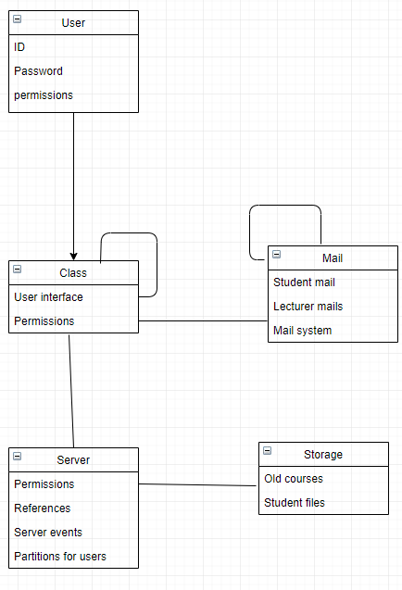

This is the domain objects associated with the use cases that are being regarded.

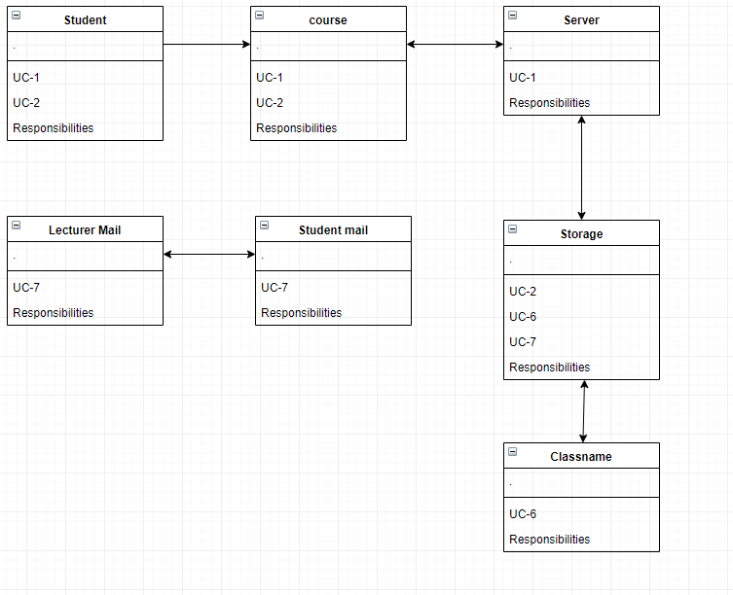

Sequence diagram for UC-1

|  |  |
| --- | --- |
| Method Name | Description |
| Element: Course | |
| Subscribe() | Creates a requested team and sets a location for them |
| Element: Database | |
| SetInfo() | Sets specified Information |
| Element: Server |  |
| AddStudent () | Add a user with student privileges to a specified location |

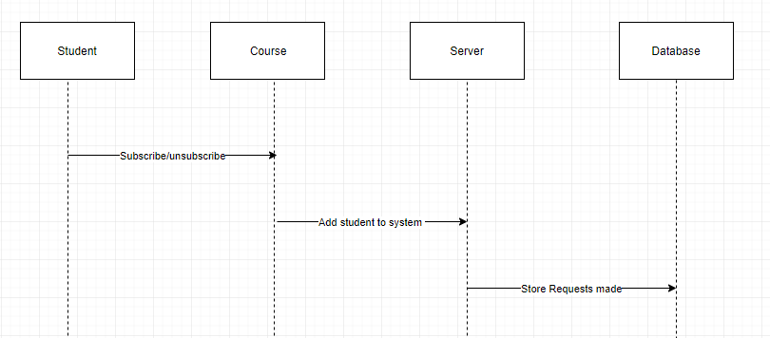

Sequence diagram for UC-2

|  |  |
| --- | --- |
| Method Name | Description |
| Element: Course | |
| MakeTeam() | Creates a requested team and sets a location for them |
| Upload() | Copies previous information as specified from the database |
| Announce() | Announce a Specified information sequence |
| Element: Database | |
| GetInfo() | Get specified information |
| SetInfo() | Sets specified Information |
| View() | Views specified information |
| Element: Mail | |
| SendMail () | Sends mail to the required place with the specified text |

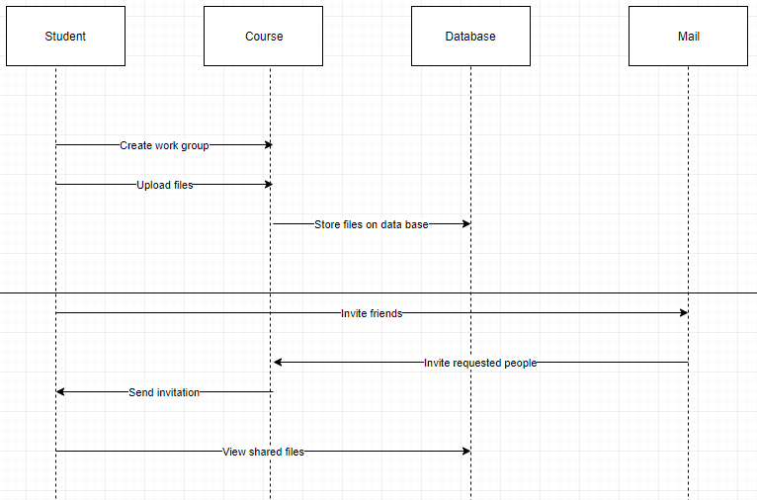

Sequence diagram for UC-6

|  |  |
| --- | --- |
| Method Name | Description |
| Element: Course | |
| SetInfo() | Sets specified Information |
| Copy() | Copies previous information as specified from the database |
| Element: Database | |
| GetInfo() | Get specified information |
| SetInfo() | Sets specified Information |
| Element: Server | |
| SetGrading() | Sets a specified grading scheme from the course |
| Set(TA, “name”) | Multiuse argument, one possible use is to set a TA with a specified name |
| Store(course) | Stores all the specified information and data of a course as a backup on a database |

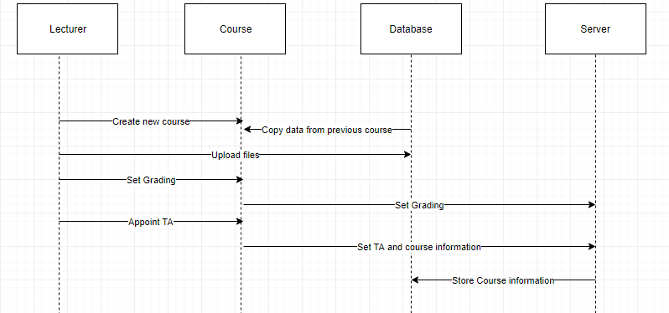

Sequence diagram for UC-7

|  |  |
| --- | --- |
| Method Name | Description |
| Element: Mail | |
| SendMail () | Sends mail to the required place with the specified text |
| Element: Course | |
| UploadMail() | Uploads the mail to the course board for display. |
| ForwardMail(Mail) | Takes a mail and forwards it to all the students in a course |

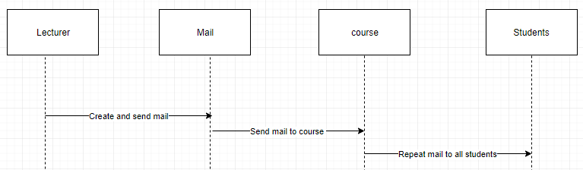

**Step 7: Perform Analysis of Current Design an Review Iteration Goal and Achievement of Design Purpose**

|  |  |  |  |
| --- | --- | --- | --- |
| Not Addressed | Partially Addressed | Completely Addressed | Design Decisions Made During the Iteration |
|  |  | UC-1 | Selected appropriate domain model for this use case. Furthermore, selected the proper sequence diagram that would describe the appropriate use case. |
|  |  | UC-2 | Selected appropriate domain model for this use case. Furthermore, selected the proper sequence diagram that would describe the appropriate use case. |
|  |  | UC-6 | Selected appropriate domain model for this use case. Furthermore, selected the proper sequence diagram that would describe the appropriate use case. |
|  |  | UC-7 | Selected appropriate domain model for this use case. Furthermore, selected the proper sequence diagram that would describe the appropriate use case. |
| CON -8 |  |  | No relevant decisions made, as it is necessary to identify the elements that participate in the use case associated with the scenario. |
| QA-1 |  |  | No relevant decisions made, as it is necessary to identify the elements that participate in the use case associated with the scenario. |
| QA-2 |  |  | No relevant decisions made, as it is necessary to identify the elements that participate in the use case associated with the scenario. |
| QA-5 |  |  | No relevant decisions made, as it is necessary to identify the elements that participate in the use case associated with the scenario. |
| QA-6 |  |  | No relevant decisions made, as it is necessary to identify the elements that participate in the use case associated with the scenario. |
| QA-7 |  |  | No relevant decisions made, as it is necessary to identify the elements that participate in the use case associated with the scenario. |
| CON-2 |  |  | No relevant decisions made, as it is necessary to identify the elements that participate in the use case associated with the scenario. |
| CON-2 |  |  | No relevant decisions made, as it is necessary to identify the elements that participate in the use case associated with the scenario. |